

- 2026)
T Arun
2520030456
AIDS
CO-1 Tress & Balanced Search Structures

Case Study Topic: Travel Flow Route Management using AVL Tree
Work Done Summary
In this case study, we implemented an AVL Tree for the Travel Flow Smart Travel Booking System. The AVL Tree stores Route IDs of flights, trains, and buses in balanced order to perform fast searching and insertion operations. The system automatically balances the tree after every insertion.
Implementation Details:
- Inserted Route IDs into AVL Tree.
- Maintained balanced structure using rotations.
- Performed searching operations efficiently.
- Displayed sorted travel schedules using inorder traversal.
Result: Screenshot/ Output 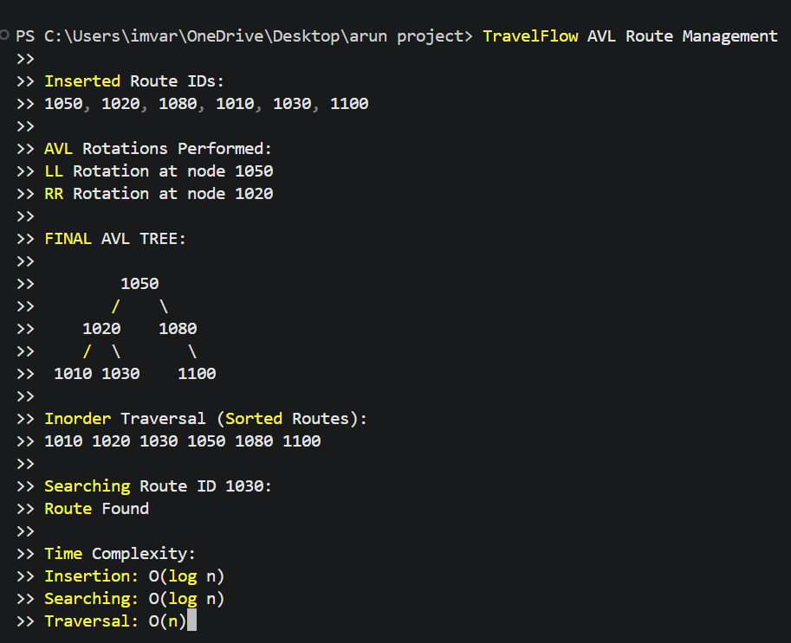
The AVL Tree provided efficient insertion, deletion, and searching operations for TravelFlow route management.
Sorted travel schedules were generated successfully using inorder traversal.

GitHub Link: https://github.com/Arun888star

